

**DEPARTMENT OF COMPUTER SCIENCE &ENGINEERING**

COLLEGE OF ENGINEERING & MANAGEMENT, KOLAGHAT

(Affiliated to West Bengal University of Technology)

Purba Medinipur-721117, West Bengal, India

**CERTIFICATE OF APPROVAL**

This is to certify that the work embodied in this project emitted **“ONLINE COUNSELING SYSTEM”** submitted by Rahuldeb Bhowmick, Satyajit Ghosh, Saikat Das, to the Department of Computer Science &Engineering, is carried out under my direct supervision and guidance.

The project work has been prepared as per the regulations of West Bengal University of Technology and I strongly recommend that this project work be accepted for the degree of B. Tech.

Supervisor

----------------------

**(Dr.Dilip Kumar Gayen)**

Assistant professor

Dept. of CSE

Counter Signed by

**--------------------------**

**Dr.Dilip Kumar Gayen**

H.O.D of Department of CSE

**DEPARTMENT OF COMPUTER SCIENCE &ENGINEERING**

COLLEGE OF ENGINEERING & MANAGEMENT, KOLAGHAT

*(*Affiliated to West Bengal University of Technology)

Purba Medinipur-721117, West Bengal, India

**Certified by the Board of Examination**

This is to certify that the work embodied in this project emitted **“ONLINE COUNSELING SYSTEM”** submitted by Rahuldeb Bhowmick, Saikat Das, Satyajit Ghosh to the Department of Computer Science &Engineering of College of Engineering & Management, Kolaghat has been examined and evaluated.

The project work has been prepared as per the regulations of West Bengal University of Technology and qualifiers to be accepted in partial fulfilment of the requirement for the degree of B. Tech.

**Board of Examiners**

**---------------------------**

**Project Coordinator**

**----------------------------**

**ACKNOWLEDGEMENT**

It gives us great pleasure to find an opportunity to express our deep and sincere gratitude to our project guide **Dr Dilip Kumar Gayen**We do very respectfully recollect his constant encouragement, kind and keen interest throughout the course of our work. We are highly indebted to him for the way he modelled and structured our work with his valuable tips and suggestions that he accorded to us in every respect of our work.

We are extremely grateful to the Department of Computer Science & Engineering, CEMK, for extending all the facilities of our department.

Last but not the least, we would like to convey our heartiest thanks to all our classmates who time have helped us with their valuable suggestions during our project work.

Rahuldeb Bhowmick

Date: University Roll: 10700111066

University Reg No:11107012004

Satyajit Ghosh

University Roll: 10700111066

University Reg No:11107012005

Saikat Das

University Roll: 11107012004

University Reg No:11107012006

**ABSTRACT**

People have used the context of network for decades as a tool for representing

complex related databases. Here is an attempt to simplify that effort and implement thetechnology for the college so that all students, teachers and other staff are benefitte from it on account of academic development, professional encouragement and improve the time consuming process of counselling .

We, the students of CEMK have tried to simplify the process of counseling for student those are stayed in remote area and need vast amount of time and expenditure use of this website we try to solve this. In terms of Computer Science and Engineering department in learning web development and other online profile management process with the help of this online tool.

.

INDEX

**TOPIC NAME Page**

.

1.Title of the project 6

2.Introduction 6

3.Objective 7

4.Feature of the project 7

5.Scope 8

6.Preliminary Idenfication 8

7.Feasibility Study 9-10

8.Hardware software specification 11

9.Project module 12

10.SRS 13

10.1 Purpose 13

10.2 Functional requirement 14

10.3 Non functional requirements 15

11.Use case diagram 16

12. Sequencial diagram 17-18

13.Class diagram 19-20

14.E-R diagram 21

15.DFD diagram 22

16.Sceneshot 23-25

17.Database Table 26-27

18.colclusion 28

19.Bibliography 28

Title of the project:

“ONLINE COUNCILING SYSTEM”

**INTRODUCTION:-**

The main objective of this project is to computerised various phases of counselling, from form submission of an candidate till allotment of the college. Various steps involved are—

1. Form submission
2. Student database
3. Acknowledgement and reporting
4. Merit list
5. College allotment details

This project is helpfull in conducting exams and providing appropriate results online.This project make the process of counselling less time consuming and easy for those who are more or less dependent technology for their daily problems.

The main purpose in online examination counselling system is to provide a way for easy and fruitful management of all components included in counseciling.

OBJECTIVE OF THE PROJECT:

The main objective in online examination counselling system is to provide a way for easy and fruitful management of all components included in counseciling.

As developers we have perceived the information as –

1. To provide a counselling service for the students.
2. It manages the database of the students on the basis of higher secondary results.
3. To allot colleges according to merit list.
4. To maintain a final allotment for the students.

FEATURES OF THE PROJECT:

Reporting or registering section:

The student can register its data through a log_in id which is unique for every student and a separate database its maintain for each students or users.

Examination section:

All the students are allotted an examination centre along with the respective details and exam is conducted with respect to the allotted centre and further result is declared.

Final allotment:

The college is allotted according to their merit list and grades are displayed for conformation.

SCOPE OF THE PROJECT:

A scope statement is on of the most critical pieces of a project, and writing one can be a difficult task for a project manager-no matter what type of project management methodology is being used.But, an effectively written scope statement can help the rest of the project flow along with minimal problems.

1. To provide a counselling service for the students.
2. It manages the database of the students on the basis of higher secondary results.
3. To allot colleges according to merit list.
4. To maintain a final allotment for the students.

PRELIMINARY IDENFICATION/ LITERATURE SURVEY:

The first phase of the system development is preliminary investigation. Due to limited resources an organization can undertake only those projects that are critical to its mission, goals and objectives.

The preliminary investigation phase sets the stage for gathering information about the current problem and the existing information system

**FEASIBILITY STUDY**

**TECHNICAL FEASIBILITY STUDY**

Technical feasibility centers on the existing manual system of the booking management process and to what extent it can support the system. According to feasibility analysis procedure the technical feasibility of the system is analyzed and the technical requirements such as software facilities, procedure, inputs are identified. It is also one of the important phases of the system development activities. The system offers greater levels of user friendless combined with greater speed.

**SCHEDULE FEASIBILITY STUDY**

It is used for determine the time factor related to the system

**SOCIAL FEASIBILITY STUDY**

It is used to determine whether a proposed project will be acceptable to the people or not. This determination typically calculates the probability of the project being accepted by the group directly affected by the proposed system change.

**MARKETING FEASIBILITY STUDY**

It is used to determine the single and multi-dimensional market forces that affect the current system. There are four types of marketing feasibility study, which are as follows:

**ECONOMIC FEASIBILITY STUDY**

Economic analysis is most frequently used for evaluation of the effectiveness of the system. More commonly known as cost/benefit analysis the procedure is to determine the benefit and saving that are expected from a system and compare them with costs, decision is made to design and implement the system.

**BEHAVIOURAL FEASIBILITY STUDY**

People are inherently resistant to change and computer has been known to facilitate changes. An estimate should be made of how strong the user is likely to move towards the development of computerized system.

**ORGANIZATIONAL FEASIBILITY STUDY**

It is mainly related to human organization. The points to be considered are

* What changes will be brought with the system?
* What new skills will be required?

**SCHEDULE FEASIBILITY STUDY**

It is mainly related to the time duration of the project. It also considers that the project is socially feasible or not. The developer required only two month to develop website

**HARDWARE**

PROCESSOR : 1.60 GHZ AND ABOVE

MEMORY(PRIMARY) : 10 GB AND ABOVE

HARD DISK : 40 GB AND ABOVE

INNPUT DEVIC : MULTIMEDIA KEYBOARD AND MICROPRSOFT

MOUSE OR COMPATIBLE PAINTING DEVICE

OUTPUT DEVICE : VDU (VISUAL DISPLAY UNIT) (COLOR MONITOR)

OPERATING SYSTEM: WINDOWS XP WITH SERVICE PACK 2 OR ABOVE

**SOFTWARE**

**ADMINISTRATOR:-**

*ADOBE DREAMWEAVER CS6

*XAMPP

*MICCROSOFT SQL SERVER 2008

**USER:-**

*PERSONAL COMPUTER

*WEB BROWSER

*INTERNET CONNECTION

**LANGUAGE USED:-**

1.HTML,,JAVASCRIPT2.PHP

**PROJECT MODULES:**

|  |  |
| --- | --- |
| **Module Name** | **Description** |
| Registration module | In this module, the functionalities of the administrator are mentioned and successfully tested. |
| Examination module | In this module, student details are entered and are stored in database. |
| College allotment module | In this module, colleges are allotted to the students according their merit list |

**TECHNOLOGY USED:**

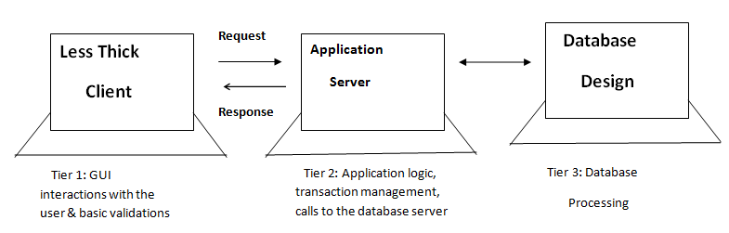

**SOFTWARE REQUIREMENT SPECIFICATION(SRS):-**

A Software Requirements Specifications (SRS) is a complete description of the behavior of the system to be developed. It includes set of use cases that describe all the interactions the users will have with the software. Use cases are also known as fundamental requirements. In addition to use cases, the SRS also contains non-functional requirements. Non-functional requirements are requirements which impose constraints on the design or implementation. The specification document describes the efficiency that will be provided by the software application “Online Examination counselling System”.

PURPOSE:

The purpose of Online examination counseling is aimed to provide the students facility to get enrolled in the examination for getting admission in technical colleges.According to their eligibility they get a college list.They choose college from that list and enrolled himself in the college.

FUNCTIONAL REQUIREMENTS:

Student section:

1. Student put his enrolment_id and get their result status.
2. Student can view list of the colleges names available for admission.
3. Student can see number of seats available in respective colleges.
4. Then student can choose three college from the college list.
5. Student can choose their stream as per their like in respective colleges.
6. Student Can Apply for admission in respective college.

Admin section:

1. This section can be accessed by providing administrator login_id and password. In this section the administrator can save and manipulate the information related to student, number of available colleges, no. Of seat available,
2. Administrator can also update list, number of seat available in respective colleges and streams till date.

Non Functional Requirements :

## Usability:

* The system shall allow the users to access the system from the Internet using HTML or it’s derivative technologies. The system uses a web browser as an interface.
* Since all users are familiar with the general usage of browsers, no specific training is required.
* The system is user friendly and self-explanatory.

**Reliability**: The system will consistently perform its intended function.

For e.g.The important information must be validated.

**Efficiency**: Unnecessary data will not be transmitted on the network and database server will be properly connected.

**Reusability**: The system can be reused in any organization or site of the same group, by defining the organization master definition under software license agreement.

Integrity:Only System Administrator has rights to access the database, not every user can access all the information. Each user will be having rights to access the modules.

USECASE DIAGRAM:

USER

ADMIN

SEQUENCE DIAGRAM:

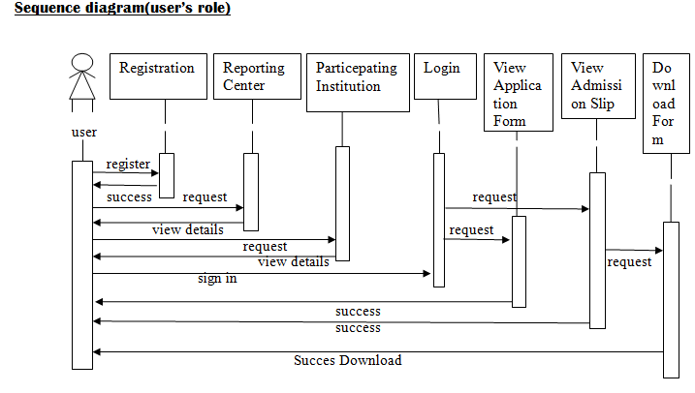

Sequence diagram(Admin role):

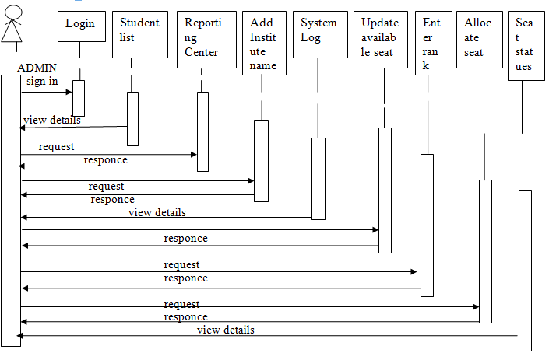

**CLASS DIAGRAM:**

**Student rank info**

#roll no:int

#rank:int

+add data()

+View()

+counsellng()

**Reporting center**

#roll no:varchar

#time:varchar

#date:varchar

+view details()

+add data()

**Student info for admin**

#name:varchar

#parents:varchar

#address:varchar

#sex:varchar

#DOB :varchar

#catagory:varchar

#age:number

#email-id:varchar

#contactno:numbr

#state:varchar

#password:varchar

#img:varchar

#roll no:int

#rank:int

#H.S %:int

#passing yr:varchar

#1st college:varchar

#stream1:varchar

#stream2:varchar

#2ndcollege:varchar

#stream1:varchar

#stream2:varchar

#3rd college:varchar

#stream1:varchar

#stream2:varchar

#passsword:varcha

+view details()

+login()

+logout()

+view fir()

+update profile()

**Student qualification details**

#roll no:int

#rank:int

#H.S %:int

#passing yr:varchar

#1st college :varchar

#stream1:varchar

#stream2:varchar

#2nd college:varchar

#stream1:varchar

#stream2:varchar

#3rd college:varchar

#stream1:varchar

#stream2:varchar

#passsword:varchar

+registration()

+submit()

+logout()

**Student personal details**

#name:varchar

#parents:varchar

#address:varchar

#sex:varchar

#DOB :varchar

#catagory:varchar

#age:number

#email-id:varchar

#contactno:numbr

#state:varchar

#password:varchar

#img:varchar

+registration().

+next()

Online Counselling System

#title:tring

#session:string

+islogin()

Online Counselling System

#title:tring

#session:string

+islogin()

**College details for user**

#college id:int

#name:varchar

#address:varchar

#URL:varchar

#CS:varchar

#IT:varchar

#ECE:varchar

#EE:varchar

#ME:varchar

+add data()

+view details()

**General candidate**

#name:varchar

#roll no:int

#rank:int

#f1 college:varchar

#f2 college:varchar

#f3 college:varchar

+counselling()

#name:varchar

#

**Non-general candidate details**

#name:varchar

#roll no:int

#rank:int

#f1 college:varchar

#f2 college:varchar

#f3 college:varchar

+counselling()

**Result table**

#name:varchar

#roll no:int

#rank:int

#H.S %:int

#address:varchar

#sex:varchar

#DOB :varchar

#catagory:varchar

#age:number

#email-id:varchar

#contactno:numbr

#state:varchar

#H.S %:int

#H.S yr:varchar

#selected college name: varchar

#selected stream name:varchar

#img:varchar

+view details()

**College seat details for system**

#college id:int

#collegename:varchar

#no. of seatCS:varchar

#no.ofseatECE:varchar

#no. of seatIT:varchar

#no.ofseatME:varchar

#no.ofseatEE:varchar

+add data()

+view details()

E-R DIAGRAM:

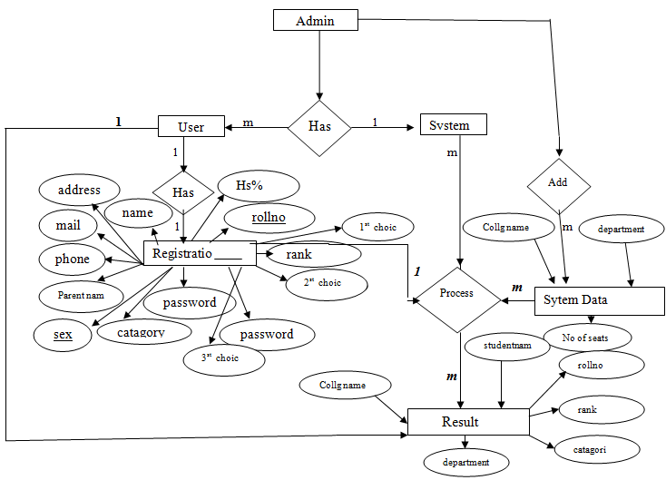

**Data Flow Diagram(DFD):**

USER

ADMIN

***Level 0:***

**QUERY REQUEST**

**RESPONSE RESPONSE WITH VALID INFO**

***Level 1:***

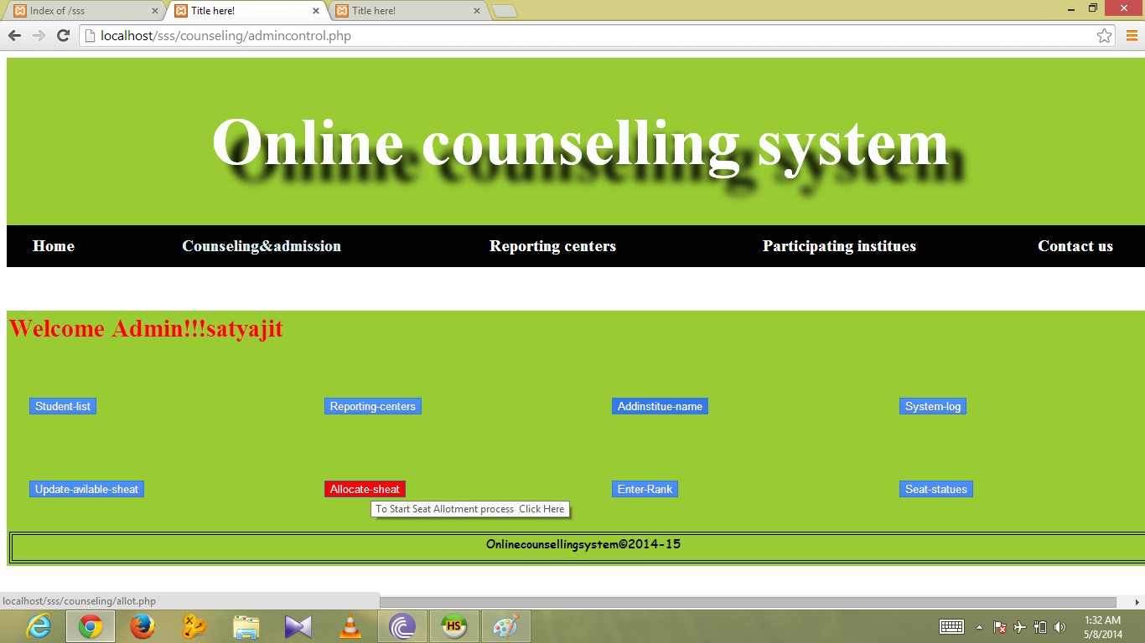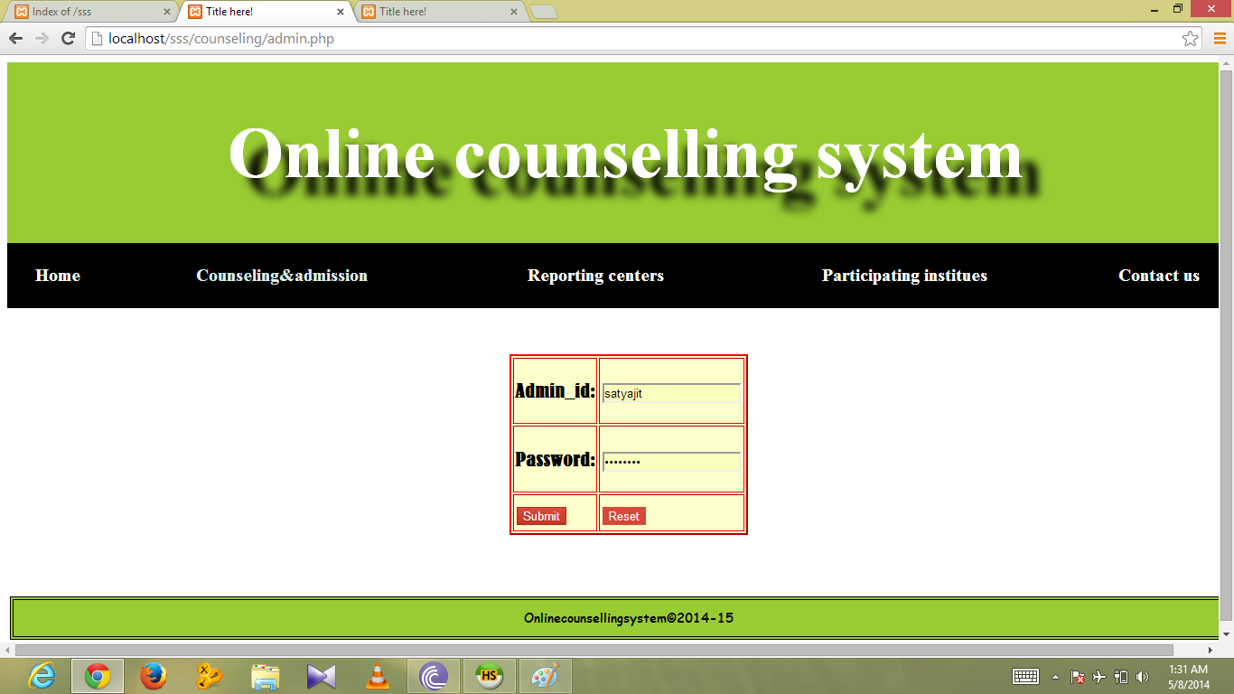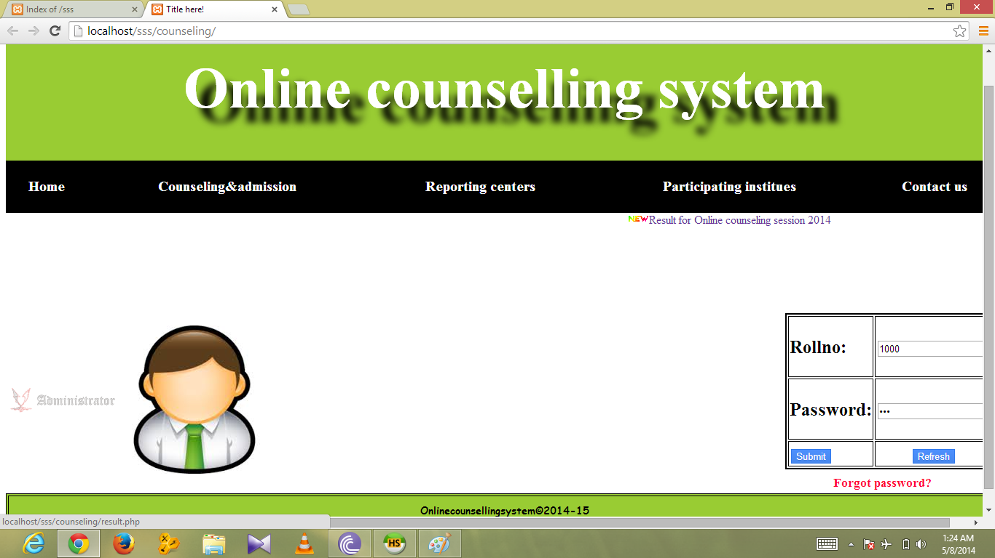

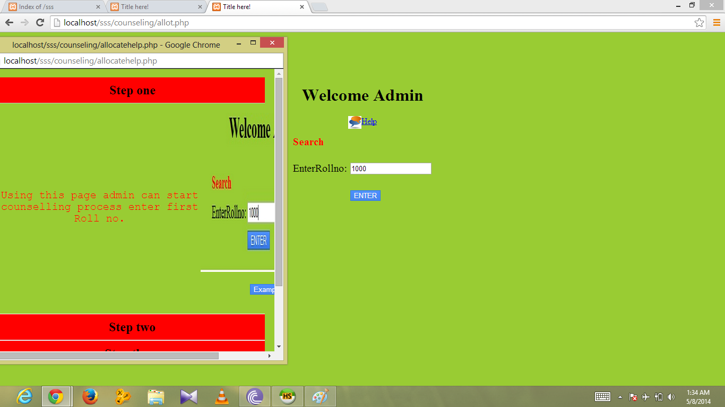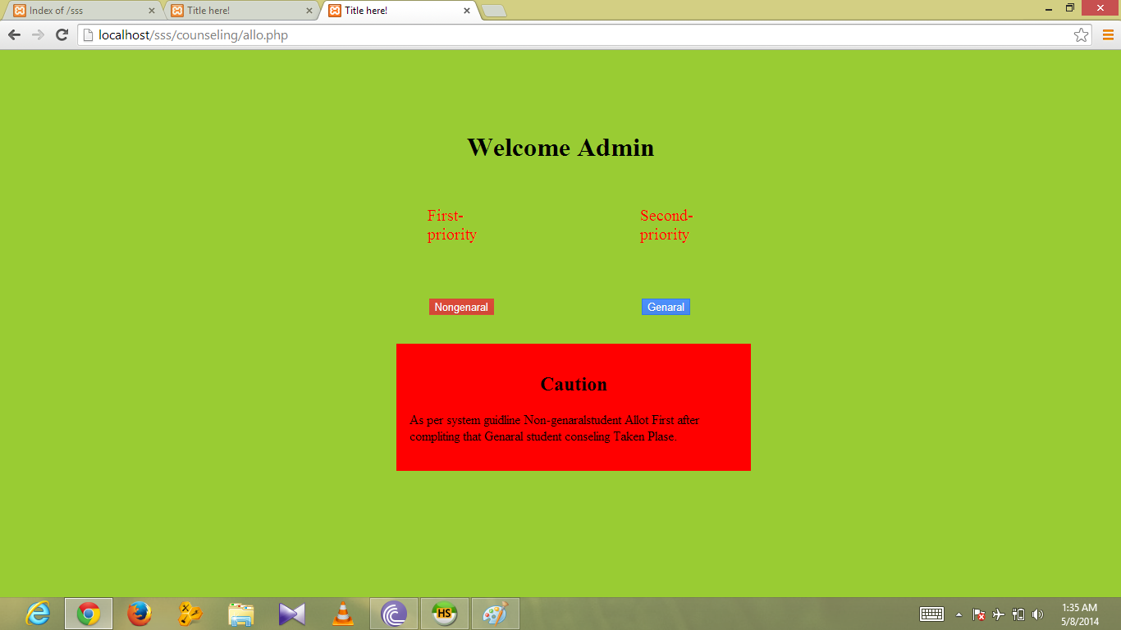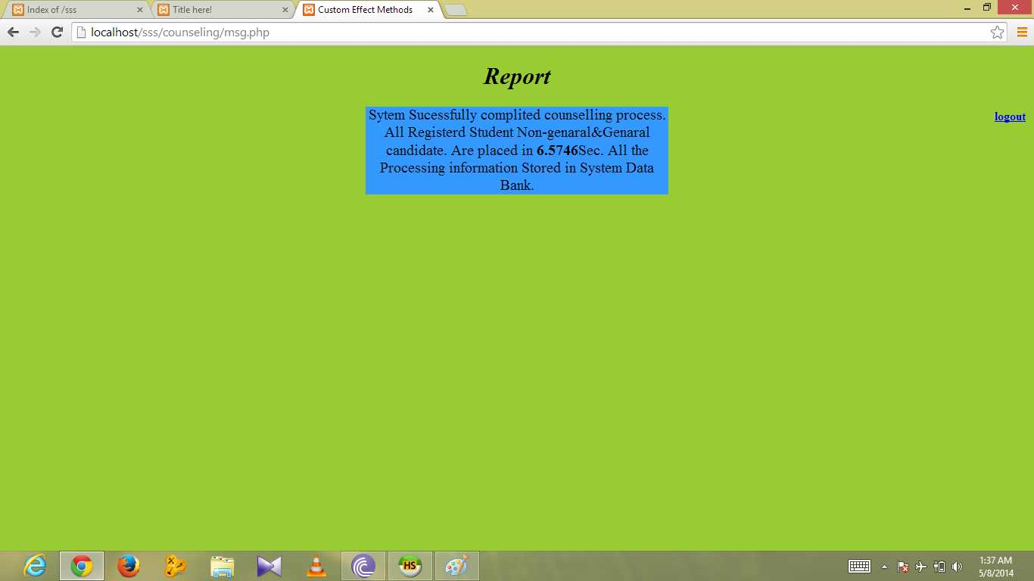

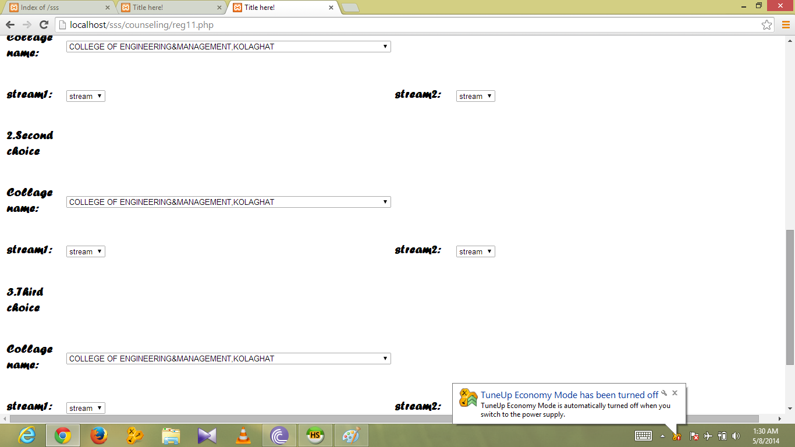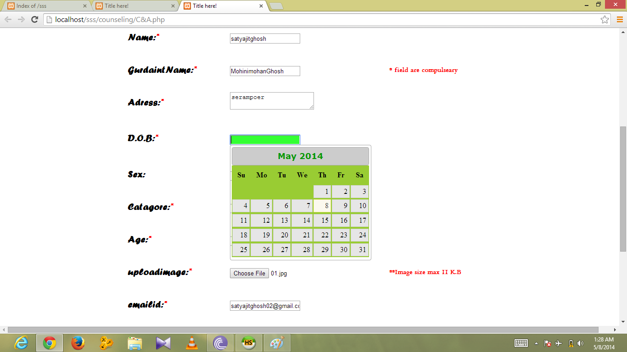

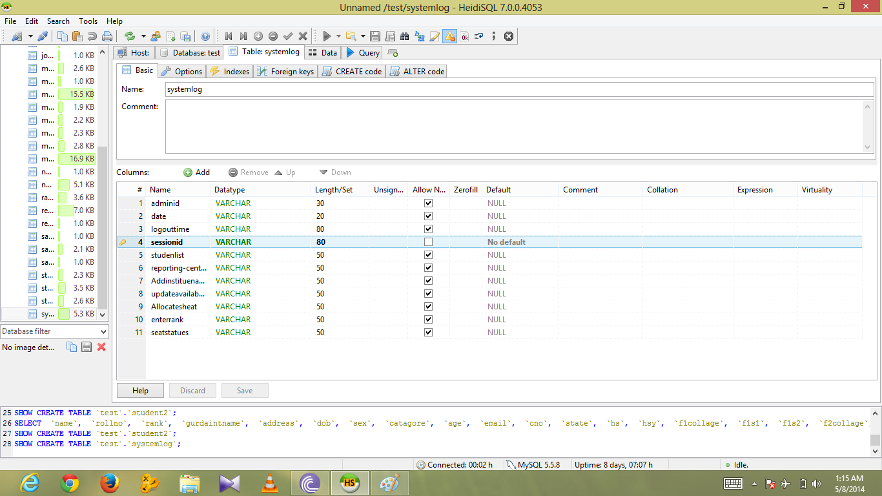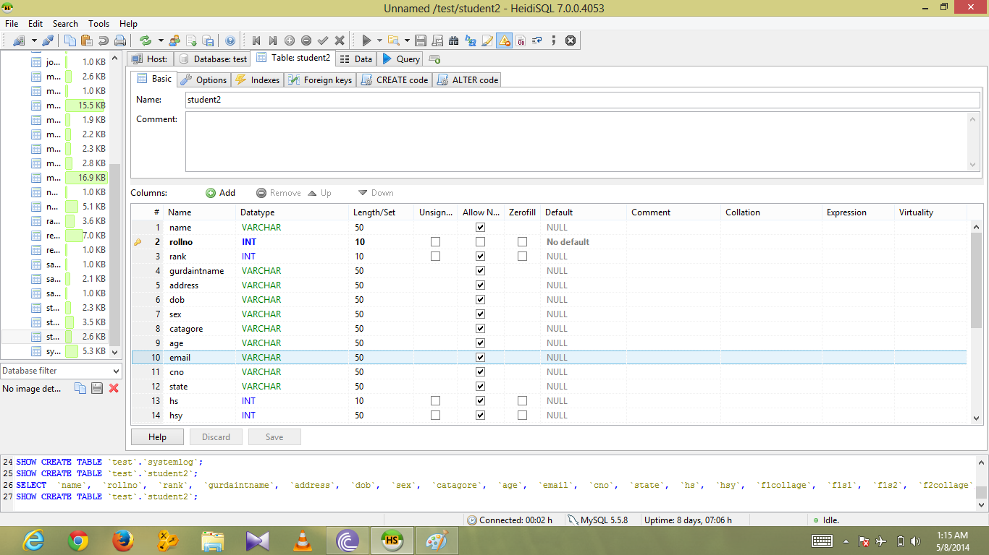

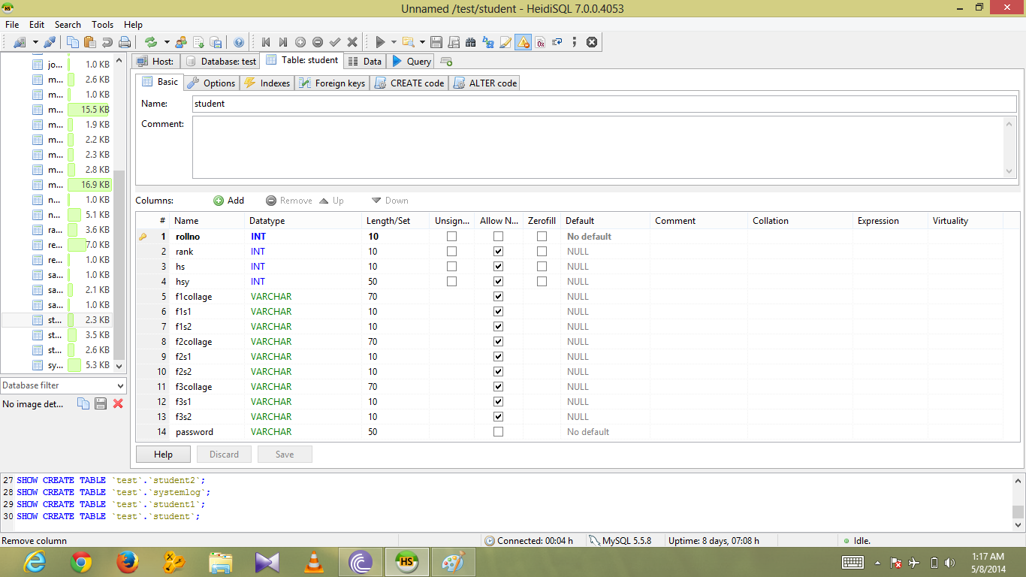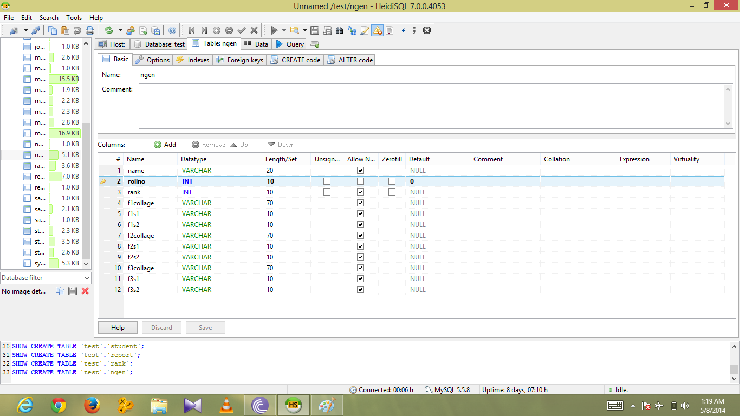

**CONCLUSION:-**

We hope our application will be a fully developed project with integration of different fields and modules of the application to ensure benefits.

As per as our project concerned, we have completed our project.Butstill we hope that it is a good approach towards developing a fully computerized online counseling procedure which can be used for conducting counseling in future.

**BIBLIOGRAPHY:-**

**BOOKS**

[1] Abraham Siberschatz **Database System Concept** McGraw-Hill International 7thedition

Henry F. Kort S. Sudarshan

[2] The complete reference PHP McGraw-Hill International by Steven Holzner

website

[www.w3schools.com](http://www.w3schools.com)

[www.php.net/tut.php](http://www.php.net/tut.php)